Programming with Python

By Randal Root

Module 10

So far, we have spent all our time creating Console applications, but millions of users find the command shell to be intimidating and unintuitive. In this lesson, we look at how to create a windowed user interface!

Creating a UI with TK Interface 1

*Window Root* 2

*Widgets* 3

Layout Managers 4

Lab 10-1 6

*Tk vs. Ttk* 6

Organizing your Code 7

Creating a UI Class 7

Lab 10-2 9

Working with Buttons 9

Lab 10-3 10

Entry (Textbox) 11

Spanning Multiple Cells 14

Getting Entry Data 14

Lab 10-4 17

Text (Multi-line Textbox) 17

Lab 10-5 21

Summary 21

References 22

# Creating a UI with TK Interface

TK Interface, or Tkinter, "… is the standard Python interface to the Tk GUI toolkit, and is Python's de facto standard GUI. Tkinter is included with standard Linux, Microsoft Windows and Mac OS X installs of Python." (<https://en.wikipedia.org/wiki/Tkinter,2019>)

You create a Tk interface using **a collection of** "**Widgets**." Common widgets include buttons, textboxes, labels, and tabs. (Figure 1)

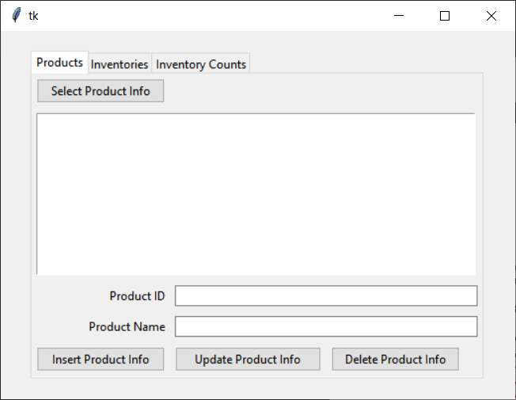

Figure 1. A common windowed interface

## Window Root

To create a windowed interface, you need **a Window**! The window **is the "root" of your user interface (UI)** and forms the top of an object Hierarchy. You can document the hierarchy using simple comments like this:

*# -- Window object -- root of the UI*

*# -- Button*

*# -- Textbox*

To make a window, you first import the "**tkinter**" **module** and then **create a window** object using the tkinter.**Tk() constructor** method. Afterward, you use the object's **mainloop()** method to **display the window**.

*# ---------------------------------------------------------- #  
# Title: Listing01  
# Description: Common components of a Windowed UI  
# ChangeLog (Who,When,What):  
# RRoot,1.1.2030,Created started script  
# ---------------------------------------------------------- #***import** tkinter **as** tk  
  
application_window = tk.Tk() *# creates a root node*application_window.mainloop() *# displays window UI*

Listing 1

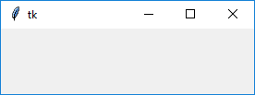

Figure 2: The results of Listing 1

## Widgets

The window is a **container for widgets**. The window includes a simple, invisible, rectangular frame.

"**Widgets** are **basically images on a computer** screen and they have a “look-and-feel” depending on the details of how the image is drawn. The “look-and-feel” of a widget is typically controlled by the operating system. For example, **GUI** programs on a **Macintosh computer typically look different** from programs on a Microsoft **Windows computer**." (<http://interactivepython.org/runestone/static/thinkcspy/GUIandEventDrivenProgramming/03_widgets.html>, 2019) [1] (External Link)

*# ---------------------------------------------------------- #  
# Title: Listing02  
# Description: Creates the following UI objects  
# -- window_root (tk.TK)  
# -- lbl_math_info (tk.label)  
# ChangeLog (Who,When,What):  
# RRoot,1.1.2030,Created started script  
# ---------------------------------------------------------- #***import** tkinter **as** tk  
  
*# Create a root node Window object*application_window = tk.Tk()  
application_window.geometry(**"400x100"**) *# Define the size of the window  
  
# Create a label object in the Window and get a reference*lbl_math_results = tk.Label(application_window, text=**"Math Results"**)  
  
*# add to the root container using the pack "layout Manager" method*lbl_math_results.pack()  
  
*# Display the window*application_window.mainloop()

Listing 2

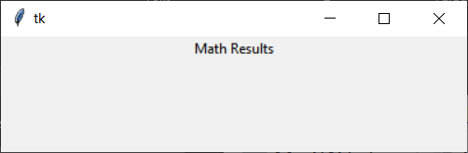

Figure 3: The results of Listing 2

When this code runs, the hierarchy of objects in memory now look like this:

# -- window_root (tk.TK)  
# -- lbl_math_info (tk.label)

## Layout Managers

You **control where widgets are placed using** **a layout manager**. These are **bound to the widget using a layout manager method** like the one in the last **example** called "**pack**()."

lbl_math_results.**pack**()

"**Just instantiating (creating) a widget does not necessarily mean that it will appear on the screen** (with the exception of Toplevel(), which automatically creates a new window). **To get the widget to appear, we need** **to tell the parent widget where to put it**. To do that, we **use** one of Tkinter's three geometery managers (also known as **layout managers**)." (<https://learn.sparkfun.com/tutorials/python-gui-guide-introduction-to-tkinter/all#tkinter-overview>, 2019) [2] (External Link)

There are **three layout managers** in the Tkinter module. Here is a good visualization and the three types of Layout managers from the learn.Sparkfun.com website tutorial [2].

|  |  |  |
| --- | --- | --- |
| **Manager** | **Description** | **Example** |
| **Grid** | The grid manager places widgets in a **table format** **with rows and columns**. It **will avoid overlapping** widgets and will resize rows/columns as necessary to fit the widgets. | Tkinter grid layout example |
| Pack | Pack is often the easiest geometry manager to use, as it just **puts widgets in a single row or column** (default). It "packs" the widgets by putting them **side-by-side (or top-to-bottom**). | Tkinter pack layout example |
| Place | The place geometry manager offers the most control but can be the most difficult to use. It allows you to **specify the absolute or relative positions of the widgets** in a window (or parent widget). | Tkinter place layout example |

" The three geometry managers are: grid, pack, and place. You should never mix geometry managers within the same hierarchy, but you can embed different managers within each other (for example, you can lay out a frame widget with grid in a Toplevel and then use pack to put different widgets within the frame)."(<https://learn.sparkfun.com/tutorials/python-gui-guide-introduction-to-tkinter/all#tkinter-overview>, 2019)[2] (External Link)

**Note:** **We use the Grid** layout manager for our labs and demos.

### Grids

"All widgets have a **.grid(row=r, column=c) method that will place a widget in the cell (r,c) of a 2-D table**. By **default** the widget is rendered in **the middle of the cell** and as small as possible. This can be changed using other optional parameters. The **sticky option allows you to move or** stretch a widget to the borders of a cell. There are 4 options, **tk.E, tk.W, tk.N, and tk.S**, which are abbreviations for east, west, north, and south respectively. These options are **‘bit flags’** that can be **combined in any combination** using simple addition." **[1]**

*# ---------------------------------------------------------- #  
# Title: Listing 03  
# Description: Creates the following UI objects  
# -- window_root (tk.TK)  
# -- lbl_math_info (tk.label)  
# -- btn_add(tk.button)  
# -- btn_subtract(tk.button)  
# ChangeLog (Who,When,What):  
# RRoot,1.1.2030,Created started script  
# ---------------------------------------------------------- #***import** tkinter **as** tk  
  
*# Create a root node Window object*application_window = tk.Tk()  
application_window.geometry(**"400x100"**)  
application_window.title(**"Simple Math"**) *# Add a titles to the Window  
  
# Create a label and add it to a grid container*lbl_math_results = tk.Label(application_window, text=**"Math Info"**)  
lbl_math_results.grid(**row=1, column=1**, sticky=tk.NW, padx=10, pady=5)  
  
*# Create a button and add it to a grid container*btn_add = tk.Button(application_window, text=**"Add"**, width=10)  
btn_add.**grid(row=2, column=1**, sticky=tk.NW, padx=10, pady=5)  
  
*# Create a button and add it to a grid container*btn_subtract = tk.Button(application_window, text=**"Subtract"**, width=10)  
btn_subtract.**grid(row=2, column=2**, sticky=tk.NW, padx=5, pady=5)  
  
*# Display the window*application_window.mainloop()

Listing 3

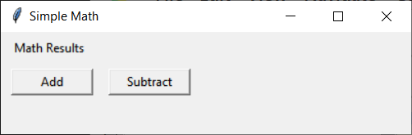

Figure 4. The result of listing 3

# Lab 10-1

Create a Window interface that looks like the following image:

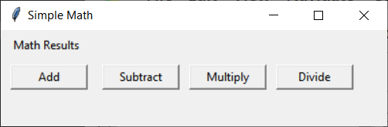

Figure 5. The result of Lab 10-1

1. Create a User Interface that looks like Figure 5.

**Note:** Try to get the look and feel close to the picture, but do not worry about minor differences!

## Tk vs. Ttk

"The tkinter module implements **two versions of widgets: one is “generic,”** which makes widgets look the same regardless of what computer your program is running on, and the other implements widgets that emulate a computer’s “look-and-feel”. How you import the tkinter module determines which widgets are defined. Using the import statements shown below, the standard convention uses the name **tk to access the “generic” widgets** and the name **ttk** to access the **stylized**, “look-and-feel” widgets**. You always need to import the tk functionality** because that allows you to create an application window. You **can import the ttk functionality if you want “look-and-feel” widgets**. You can inter-mix the tk and ttk widgets in an interface if you so choose.*"* ***[1]***

*# ---------------------------------------------------------- #  
# Title: Listing 04  
# Description: Creates the following UI objects  
# -- window_root (tk.TK)  
# -- lbl_math_info (****ttk****.label)  
# -- btn_add(****ttk****.button)  
# -- btn_subtract(****ttk****.button)  
# ChangeLog (Who,When,What):  
# RRoot,1.1.2030,Created started script  
# ---------------------------------------------------------- #***import** tkinter **as** tk  
**from** tkinter **import** ttk *# Updated look and feel  
  
# Create a root node Window object*application_window = tk.Tk()  
application_window.geometry(**"400x100"**)  
application_window.title(**"Simple Math"**) *# Add a titles to the Window  
  
# Create a label and add it to a grid container*lbl_math_results = **ttk**.Label(application_window, text=**"Math Results"**)  
lbl_math_results.grid(row=1, column=1, sticky=tk.NW, padx=10, pady=5)  
  
*# Create a button and add it to a grid container*btn_add = **ttk**.Button(application_window, text=**"Add"**, width=10)  
btn_add.grid(row=2, column=1, sticky=tk.NW, padx=10, pady=5)  
  
*# Create a button and add it to a grid container*btn_subtract = **ttk**.Button(application_window, text=**"Subtract"**, width=10)  
btn_subtract.grid(row=2, column=2, sticky=tk.NW, padx=5, pady=5)  
  
*# Display the window*application_window.mainloop()

Listing 4

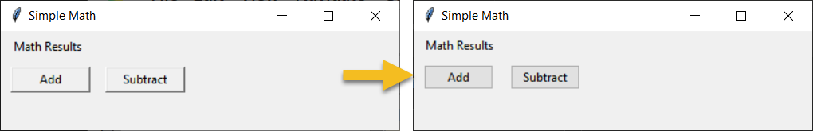

Figure 6. The results of listing 4

# Organizing your Code

Currently, there is not much code in our example, but that changes shortly. So, we should start **organizing our code using custom classes and methods**!

## Creating a UI Class

Let's **create a class to hold the code for our main window** (which runs in our main module.)

*# ---------------------------------------------------------- #  
# Title: Listing 05  
# Description: Creates a Windowed UI  
# ChangeLog (Who,When,What):  
# RRoot,1.1.2030,Created started script  
# ---------------------------------------------------------- #***import** tkinter **as** tk  
**from** tkinter **import** ttk *# Updated look and feel***class** MainWindow(object):  
 *""" Description: Creates the following UI objects:  
  
 window_root (tk.TK):  
 lbl_math_info (ttk.label):  
 btn_add (ttk.button):  
 btn_subtract (ttk.button):  
 """* @staticmethod  
 **def** create_main_window():  
 application_window = tk.Tk()  
 application_window.geometry(**"400x100"**)  
 application_window.title(**"Simple Math"**)  
  
 lbl_math_results = ttk.Label(application_window, text=**"Math Results"**)  
 lbl_math_results.grid(row=1, column=1, sticky=tk.NW, padx=10, pady=5)  
  
 btn_add = ttk.Button(application_window, text=**"Add"**, width=10)  
 btn_add.grid(row=2, column=1, sticky=tk.NW, padx=10, pady=5)  
  
 btn_subtract = ttk.Button(application_window, text=**"Subtract"**, width=10)  
 btn_subtract.grid(row=2, column=2, sticky=tk.NW, padx=5, pady=5)  
  
 **return** application_window  
*# End class***if** __name__ == **'__main__'**:  
 mw = MainWindow.create_main_window()  
 mw.mainloop()

Listing 5

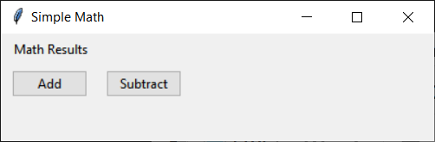

Figure 7. the result of Listing 6

# Lab 10-2

Use the demonstrated code to create a UI that looks like this:

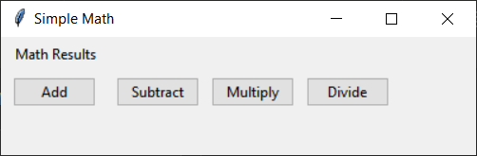

Figure 8. The result of Lab 10-2

1. Create a UI class with the indicated object names and hierarchy.

**class** MainWindow(object):  
 *""" Description: Creates the following UI objects:  
 window_root (tk.TK)  
 lbl_math_info (****ttk****.label)  
 btn_add (****ttk****.button)  
 btn_subtract (****ttk****.button)  
 btn_multiply (****ttk****.button)  
 btn_divide (****ttk****.button)   
 """*

2. Test your UI.

**Note:** Try to get the look and feel close to the picture, but do not worry about minor differences!

# Working with Buttons

To make your buttons work you need to **create a event handing function**. These functions can have zero or more parameters, but they do not return data. When **someone clicks the button the code inside the function runs**.

**Important**: You **use a lambda syntax for** the event handling method **when** there are **parameters as shown in Listing 6**!

*# ---------------------------------------------------------- #  
# Title: Listing 06  
# Description: Demonstrate using Event Handlers   
# ChangeLog (Who,When,What):  
# RRoot,1.1.2030,Created started script  
# ---------------------------------------------------------- #***import** tkinter **as** tk  
**from** tkinter **import** ttk  
  
**class** MathProcessor(object):  
 @staticmethod  
 **def** add_w_o_params(): print(5 + 5)  
  
 @staticmethod  
 **def** add_with_params(n1, n2): print(n1 + n2)  
  
**class** MainWindow(object):  
  
 **def** __init__(self):  
 self.window = tk.Tk()  
 self.window.title(**"Event Handling"**)  
 self.window.geometry(**"300x110"**)  
  
 *# Set Event handler for custom method w/o parameters* btn1 = ttk.Button(self.window, text=**"Call add_w_o_params()"**)  
 btn1.pack(pady=5)  
 **btn1['command'] = MathProcessor.add_w_o_params**  ***# don't use parentheses ()*** *# Set Event handler for custom method with parameters* btn5 = ttk.Button(self.window, text=**"Call add_with_params"**)  
 btn5.pack(pady=5)  
 **btn5['command'] = lambda: MathProcessor.add_with_params(5, 2)**  
  
 *# Set Event handler to a built-in method* btn3 = ttk.Button(self.window, text=**"Quit"**)  
 btn3.pack(pady=5)  
 **btn3['command'] = self.window.destroy *# don't use parentheses ()*****if** __name__ == **'__main__'**:  
 mw = MainWindow()  
 mw.window.mainloop()

Listing 6

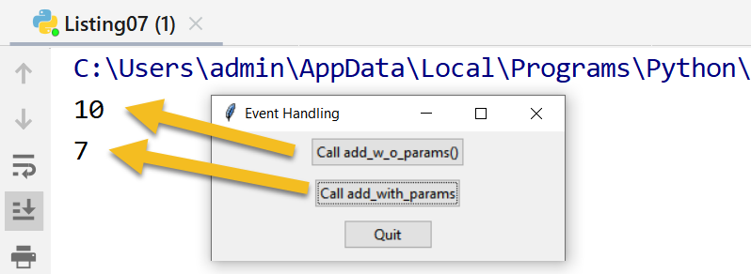

Figure 9. the results of Listing 6

# Lab 10-3

Modify the code you created in Lab 10-2 to click events. The outcome should look like this:

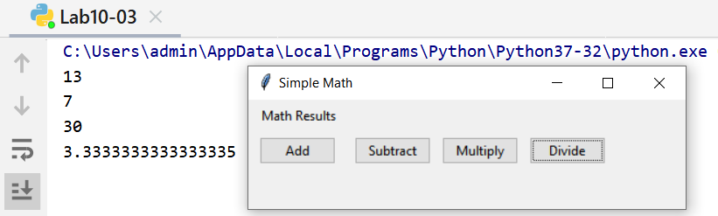

Figure 10. The results of lab 10-3

1. Create the following class:

**class** MathProcessor(object):  
 @staticmethod  
 **def** add(n1, n2): print(n1 + n2)  
  
 @staticmethod  
 **def** subtract(n1, n2): print(n1 - n2)  
  
 @staticmethod  
 **def** multiply(n1, n2): print(n1 * n2)  
  
 @staticmethod  
 **def** divide(n1, n2): print(n1 / n2)

2. Connect buttons to each method using a lambda syntax like this:

btn_add = ttk.Button(application_window, text=**"Add"**, width=10)  
btn_add.grid(row=2, column=1, sticky=tk.NW, padx=10, pady=5)  
**btn_add['command'] = lambda: MathProcessor.add(10, 3)**

# Entry (Textbox)

"The **Entry** widget is a standard Tkinter widget used to enter or display a **single line of text**.

*# ---------------------------------------------------------- #  
# Title: Listing 07  
# Description: Demonstrate using Entry textboxes  
# ChangeLog (Who,When,What):  
# RRoot,1.1.2030,Created started script  
# ---------------------------------------------------------- #***import** tkinter **as** tk  
**from** tkinter **import** ttk  
  
**class** MathProcessor(object):  
 @staticmethod  
 **def** add(n1, n2): print(n1 + n2)  
  
 @staticmethod  
 **def** subtract(n1, n2): print(n1 - n2)  
  
 @staticmethod  
 **def** multiply(n1, n2): print(n1 * n2)  
  
 @staticmethod  
 **def** divide(n1, n2): print(n1 / n2)  
  
**class** MainWindow(object):  
 *""" Description: Creates the following UI objects:  
 window_root (tk.TK)  
 lbl_math_info (ttk.label)*

***lbl_first_number (ttk.Label)*** ***txt_first_number (ttk.entry)***

***lbl_second_number (ttk.Label)  
 txt_second_number (ttk.entry)*** *btn_add (ttk.button)  
 btn_subtract (ttk.button)  
 btn_multiply (ttk.button)  
 btn_divide (ttk.button)  
 """* @staticmethod  
 **def** create_main_window():  
 *""" Create and configure a root node Window object"""* application_window = tk.Tk()  
 application_window.geometry(**"400x120"**)  
 application_window.title(**"Simple Math"**)  
  
 lbl_math_results = ttk.Label(application_window, text=**"Math Results"**)  
 lbl_math_results.grid(row=1, column=1, sticky=tk.NW, padx=10, pady=5)  
  
 lbl_first_number = ttk.Label(  
 application_window,  
 text=**"First Number "**,  
 width=20,  
 anchor=tk.E  
 )  
 lbl_first_number.grid(row=2, column=1, sticky=tk.E)  
 txt_first_number = ttk.Entry(application_window, width=10)  
 txt_first_number.grid(row=2, column=2)  
 txt_first_number.insert(0, **"0.00"**)  
  
 lbl_second_number = ttk.Label(  
 application_window,  
 text=**"Second Number "**,  
 width=20,  
 anchor=tk.E  
 )  
 lbl_second_number.grid(row=3, column=1, sticky=tk.E)  
 txt_second_number = ttk.Entry(application_window, width=10)  
 txt_second_number.grid(row=3, column=2)  
 txt_second_number.insert(0, **"0.00"**)  
  
 btn_add = ttk.Button(application_window, text=**"Add"**, width=10)  
 btn_add.grid(row=4, column=1, sticky=tk.NW, padx=10, pady=5)  
 btn_add[**'command'**] = **lambda**: MathProcessor.add(10, 3)  
  
 btn_subtract = ttk.Button(application_window, text=**"Subtract"**, width=10)  
 btn_subtract.grid(row=4, column=2, sticky=tk.NW, padx=5, pady=5)  
 btn_subtract[**'command'**] = **lambda**: MathProcessor.subtract(10, 3)  
  
 btn_multiply = ttk.Button(application_window, text=**"Multiply"**, width=10)  
 btn_multiply.grid(row=4, column=3, sticky=tk.NW, padx=5, pady=5)  
 btn_multiply[**'command'**] = **lambda**: MathProcessor.multiply(10, 3)  
  
 btn_divide = ttk.Button(application_window, text=**"Divide"**, width=10)  
 btn_divide.grid(row=4, column=4, sticky=tk.NW, padx=5, pady=5)  
 btn_divide[**'command'**] = **lambda**: MathProcessor.divide(10, 3)  
  
 **return** application_window  
*# End class***if** __name__ == **'__main__'**:  
 mw = MainWindow.create_main_window()  
 mw.mainloop()

Listing 7

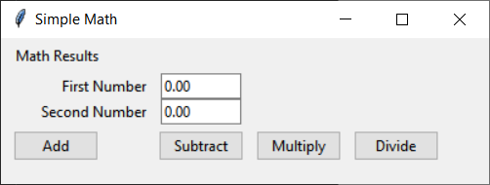

Figure 11. The results of Listing 7

## Spanning Multiple Cells

"Widgets can **take up more than a single cell in the grid**; to do this, you'll use the "columnspan" and "rowspan"options when gridding the widget. These are analogous to the "colspan" and "rowspan" attribute of HTML tables."( <https://tkdocs.com/tutorial/grid.html>, 2019)

If you look at Figure 11, you can see a grid of 4 by 4 cells, with each control is in its own cell. Figure 12 shows a visualization of these cells.

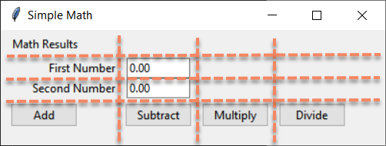

Figure 12. Imaging the control grid

However, sometimes you want a control to cover more than one cell in the grid. When that happens, you can use the columnspan parameter. For example, the following code will cause the txt_first_number textbox (Entry) control to span 3 cells in the grid as shown in Figure 14. To make the UI look the way you want you might also have to adjuct the xpad and ypad values.

*#txt_second_number.grid(row=3, column=2)*txt_second_number.grid(row=3, column=2, columnspan=3)  
txt_second_number.insert(0, **"0.00"**)  
  
btn_add = ttk.Button(application_window, text=**"Add"**, width=10)  
btn_add.grid(row=4, column=1, sticky=tk.NE, padx=5, pady=5)  
btn_add[**'command'**] = **lambda**: MathProcessor.add(10, 3)

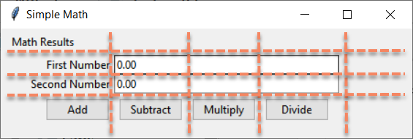

Figure 13. The results of not using columnspan and adjusted padding

## Getting Entry Data

When you want to access that data of an Entry textbox you use the **get() method** of the Entry object (Listing 8).

*# ---------------------------------------------------------- #  
# Title: Listing 08  
# Description: Demonstrate getting data from Entry textboxes  
# ChangeLog (Who,When,What):  
# RRoot,1.1.2030,Created started script  
# ---------------------------------------------------------- #***import** tkinter **as** tk  
**from** tkinter **import** ttk  
  
**class** MathProcessor(object):  
 @staticmethod  
 **def** add(n1, n2): print(n1 + n2)  
  
 @staticmethod  
 **def** subtract(n1, n2): print(n1 - n2)  
  
 @staticmethod  
 **def** multiply(n1, n2): print(n1 * n2)  
  
 @staticmethod  
 **def** divide(n1, n2): print(n1 / n2)  
  
**class** MainWindow(object):  
 *""" Description: Creates the following UI objects:  
 window_root (tk.TK)  
 lbl_math_info (ttk.label)  
 txt_first_number (ttk.entry)  
 txt_second_number (ttk.entry)  
 btn_add (ttk.button)  
 btn_subtract (ttk.button)  
 btn_multiply (ttk.button)  
 btn_divide (ttk.button)  
 """* @staticmethod  
 **def** create_main_window():  
 *""" Create and configure a root node Window object"""* application_window = tk.Tk()  
 application_window.geometry(**"450x120"**)  
 application_window.title(**"Simple Math"**)  
  
 lbl_math_results = ttk.Label(application_window, text=**"Math Results"**)  
 lbl_math_results.grid(row=1, column=1, sticky=tk.NW, padx=10, pady=5)  
  
 lbl_first_number = ttk.Label(  
 application_window,  
 text=**"First Number "**,  
 width=20,  
 anchor=tk.E  
 )  
 lbl_first_number.grid(row=2, column=1, sticky=tk.E)

txt_first_number = ttk.Entry(application_window, width=40)  
 txt_first_number.grid(row=2, column=2, columnspan=3)  
 txt_first_number.insert(0, **"0.00"**)  
  
 lbl_second_number = ttk.Label(  
 application_window,  
 text=**"Second Number "**,  
 width=20,  
 anchor=tk.E  
 )  
 lbl_second_number.grid(row=3, column=1, sticky=tk.E)

txt_second_number = ttk.Entry(application_window, width=40)  
 txt_second_number.grid(row=3, column=2, columnspan=3)  
 txt_second_number.insert(0, **"0.00"**)  
  
 btn_add = ttk.Button(application_window, text=**"Add"**, width=10)  
 btn_add.grid(row=4, column=1, sticky=tk.NE, padx=5, pady=5)  
 btn_add[**'command'**] = **lambda**: MathProcessor.add(  
 **float(txt_first_number.get()), float(txt_second_number.get())**  
 )  
  
 btn_subtract = ttk.Button(application_window, text=**"Subtract"**, width=10)  
 btn_subtract.grid(row=4, column=2, sticky=tk.NW, padx=5, pady=5)  
 btn_subtract[**'command'**] = **lambda**: MathProcessor.subtract(**7,2**))  
  
 btn_multiply = ttk.Button(application_window, text=**"Multiply"**, width=10)  
 btn_multiply.grid(row=4, column=3, sticky=tk.NW, padx=0, pady=5)  
 btn_multiply[**'command'**] = **lambda**: MathProcessor.multiply(7,2))  
  
 btn_divide = ttk.Button(application_window, text=**"Divide"**, width=10)  
 btn_divide.grid(row=4, column=4, sticky=tk.NW, padx=5, pady=5)  
 btn_divide[**'command'**] = **lambda**: MathProcessor.divide(7,2)

**return** application_window  
*# End class*

**if** __name__ == **'__main__'**:  
 mw = MainWindow.create_main_window()  
 mw.mainloop()

Listing 8

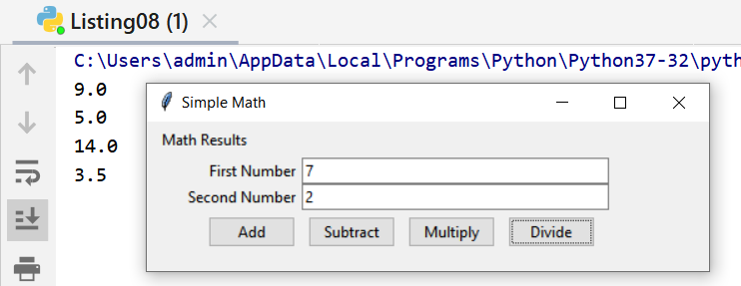

Figure 14. The results of Listing 8

# Lab 10-4

Modify the code you created in Lab 10-3 to capture data from a first and second number using Entry textboxes, then adds, subtracts, multiplies, and divides the values from the textboxes. Format the UI to look like Figure 14.

**Note:** Try to get the look and feel close to the picture, but do not worry about minor differences! If you get stuck you

# Text (Multi-line Textbox)

"A text widget **manages a multi-line text area**. Like the canvas widget, Tk's text widget is an immensely flexible and powerful tool which can be used for a wide variety of tasks." (<https://tkdocs.com/tutorial/text.html>, 2019) [4]

*# ---------------------------------------------------------- #  
# Title: Listing 09  
# Description: Demonstrate using multi-line textboxes  
# ChangeLog (Who,When,What):  
# RRoot,1.1.2030,Created started script  
# ---------------------------------------------------------- #***import** tkinter **as** tk  
**from** tkinter **import** ttk  
  
**class** MathProcessor(object):  
 @staticmethod  
 **def** add(n1, n2): **return** n1 + n2  
  
 @staticmethod  
 **def** subtract(n1, n2): print(n1 - n2)  
  
 @staticmethod  
 **def** multiply(n1, n2): print(n1 * n2)  
  
 @staticmethod  
 **def** divide(n1, n2): print(n1 / n2)  
  
  
**class** MathIO(object):  
  
 @staticmethod  
 **def** clear_textbox(textbox):  
 textbox[**'state'**] = **'normal'** textbox.delete(1.0, tk.END)  
 textbox[**'state'**] = **'disabled'** @staticmethod  
 **def write_sum_to_textbox**(n1, n2, textbox):  
 textbox[**'state'**] = **'normal'  
 text** = str.format(**'The Sum of {n1} and {n2} is {result}\n'**,  
 n1=n1, n2=n2, result=**MathProcessor.add**(n1, n2))  
 textbox.insert(tk.END, text)  
 textbox[**'state'**] = **'disabled'** @staticmethod  
 **def** write_difference_to_textbox(n1, n2, textbox):  
 textbox[**'state'**] = **'normal'** text = str.format(**'The difference of {n1} and {n2} is {result}\n'**,  
 n1=n1, n2=n2, result=MathProcessor.subtract(n1, n2))  
 textbox.insert(tk.END, text)  
 textbox[**'state'**] = **'disabled'** @staticmethod  
 **def** write_product_to_textbox(n1, n2, textbox):  
 textbox[**'state'**] = **'normal'** text = str.format(**'The product of {n1} and {n2} is {result}\n'**,  
 n1=n1, n2=n2, result=MathProcessor.multiply(n1, n2))  
 textbox.insert(tk.END, text)  
 textbox[**'state'**] = **'disabled'** @staticmethod  
 **def** write_quotient_to_textbox(n1, n2, textbox):  
 textbox[**'state'**] = **'normal'** text = str.format(**'The quotient of {n1} and {n2} is {result}\n'**,  
 n1=n1, n2=n2, result=MathProcessor.divide(n1, n2))  
 textbox.insert(tk.END, text)  
 textbox[**'state'**] = **'disabled'***# End class***class** MainWindow(object):  
 *""" Description: Creates the following UI objects:  
 window_root (tk.TK)  
 lbl_math_info (ttk.label)  
 txt_first_number (ttk.entry)  
 txt_second_number (ttk.entry)  
 mtx_results (ttk.textbox)  
 btn_add (ttk.button)  
 btn_subtract (ttk.button)  
 btn_multiply (ttk.button)  
 btn_divide (ttk.button)  
 """* @staticmethod  
 **def** create_main_window():  
 *""" Create and configure a root node Window object"""* application_window = tk.Tk()  
 application_window.geometry(**"425x250"**)  
 application_window.title(**"Simple Math"**)  
  
 lbl_math_results = ttk.Label(application_window, text=**"Math Results"**)  
 lbl_math_results.grid(row=1, column=1, sticky=tk.NW, padx=10, pady=5)  
  
 lbl_first_number = ttk.Label(  
 application_window,  
 text=**"First Number "**,  
 width=20,  
 anchor=tk.E  
 )  
 lbl_first_number.grid(row=2, column=1, sticky=tk.E)  
 txt_first_number = ttk.Entry(application_window, width=40)  
 txt_first_number.grid(row=2, column=2, columnspan=3)  
 txt_first_number.insert(0, **"0.00"**)  
  
 lbl_second_number = ttk.Label(  
 application_window,  
 text=**"Second Number "**,  
 width=20,  
 anchor=tk.E  
 )  
 lbl_second_number.grid(row=3, column=1, sticky=tk.E)  
 txt_second_number = ttk.Entry(application_window, width=40)  
 txt_second_number.grid(row=3, column=2, columnspan=3)  
 txt_second_number.insert(0, **"0.00"**)  
  
 *# Adding a multi-line textbox***mtx_results = tk.Text(width=50, height=5)** mtx_results.grid(row=4,  
 column=1,  
 sticky=tk.N,  
 columnspan=4,  
 padx = 10,  
 pady =10  
 )  
  
 btn_add = ttk.Button(application_window, text=**"Add"**, width=10)  
 btn_add.grid(row=5, column=1, sticky=tk.E, padx=15, pady=5)  
 btn_add[**'command'**] = **lambda: MathIO.write_sum_to_textbox(  
 float(txt_first_number.get()),  
 float(txt_second_number.get()),  
 mtx_results)**  
  
 btn_subtract = ttk.Button(application_window, text=**"Subtract"**, width=10)  
 btn_subtract.grid(row=5, column=2, sticky=tk.W, padx=5, pady=5)  
 btn_subtract[**'command'**] = \  
 **lambda**: MathProcessor.subtract(10, 3)  
  
 btn_multiply = ttk.Button(application_window, text=**"Multiply"**, width=10)  
 btn_multiply.grid(row=5, column=3, sticky=tk.W, padx=5, pady=5)  
 btn_multiply[**'command'**] = \  
 **lambda**: MathProcessor.multiply(10, 3)  
  
 btn_divide = ttk.Button(application_window, text=**"Divide"**, width=10)  
 btn_divide.grid(row=5, column=4, sticky=tk.W, padx=5, pady=5)  
 btn_divide[**'command'**] = \  
 **lambda**: MathProcessor.divide(10, 3)  
  
 btn_divide = ttk.Button(application_window, text=**"Clear Results"**, width=55)  
 btn_divide.grid(row=6, column=1, padx=15, pady=5, columnspan=4)  
 btn_divide[**'command'**] = **lambda**: MathIO.clear_textbox(mtx_results)  
 **return** application_window  
*# End class***if** __name__ == **'__main__'**:  
 mw = MainWindow.create_main_window()  
 mw.mainloop()

Listing 9  
  
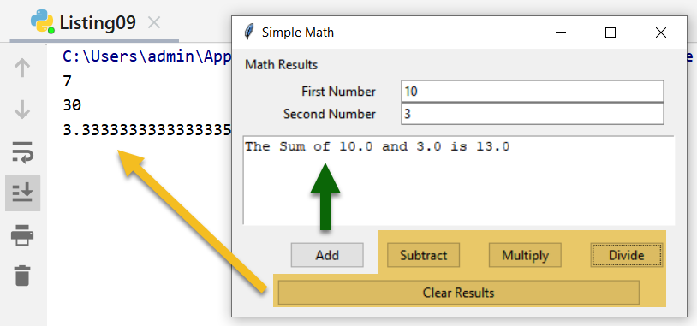

Figure 15. The results of listing 9

# Lab 10-5

Modify the code you created in Lab 10-3 to capture data from a first and second number using Entry textboxes, then adds, subtracts, multiplies, and divides the values from the Entry textboxes and add the results to a multi-line textbox. Format the UI to look like Figure 16.

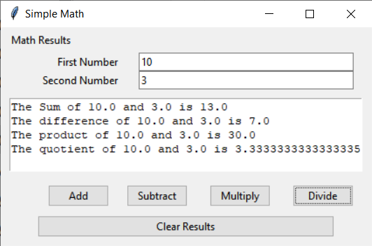

Figure 16. Result of the lab 10-5

**Note:** Try to get the look and feel close to the picture, but do not worry about minor differences! If you get stuck you

# Summary

In this module, we looked at how to create a windowed user interface. This process is substantially harder code than a console user interface, so you may want to continue to use a console UI for now, but as you become a more experienced programmer you will find that a Windowed use is much appreciated!

At this point, you should try and answer as many of the following questions as you can from memory, then review the subjects that you cannot. Imagine being asked these questions by a co-worker or in an interview to connect this learning with aspects of your life.

* What is the difference between a console and a windowed UI?
* What are the pros and cons of a windowed UI?
* What is Event Handling?
* What are Widgets?

When you can answer all of these from memory, it is time to complete the module's assignment and complete the course.

# References

1. Runestone, GUI and Event Driven Programming

<http://interactivepython.org/runestone/static/thinkcspy/GUIandEventDrivenProgramming/toctree.html>, 2019, (External Link)

2. Python GUI Guide: Introduction to Tkinter

<https://learn.sparkfun.com/tutorials/python-gui-guide-introduction-to-tkinter/all#tkinter-overview>, 2019, (External Link)

3. Effbot.org, tkinterbook

<https://effbot.org/tkinterbook/>, 2019, (External Link)

4. TkDocs.org, tutorial

<https://tkdocs.com/tutorial/text.html>, 2019, (External Link)